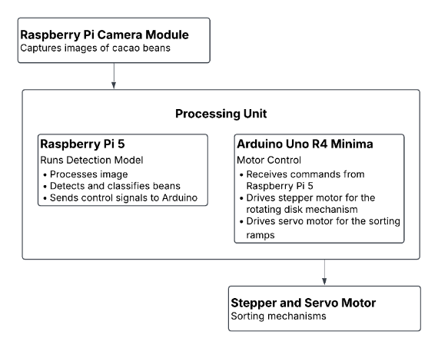
SYSTEM ARCHITECTURE

This system architecture is designed to automatically classify and sort cacao beans. The Raspberry Pi Camera Module captures images of the cacao beans and sends them to the Raspberry Pi 5 for image processing and classification. Based on the detection result, the Raspberry Pi 5 sends control commands to the Arduino Uno R4 Minima. The Arduino then controls the stepper motor for the rotating disk mechanism and the servo motor for the sorting ramps, allowing the beans to be automatically sorted according to their classification.

